Jennifer Swinton
Capstone Artifact One Narrative

Discuss the following prompts:
- Briefly describe the artifact. What is it? When was it created?
This artifact is a custom 3D graphic rendering inspired by Indianapolis’s Monument Circle. While the real location is far more complex and detailed, this version is intentionally simplified to fit the project scope and allow for creative experimentation. Several artistic liberties were taken to explore different material behaviors, lighting effects, and scene composition. The original version of this artifact was created in 2023, and the enhanced version was completed during this course.
- Justify the inclusion of the artifact in your ePortfolio. Why did you select this item? What specific components of the artifact showcase your skills and abilities in software development? How was the artifact improved?
I chose this artifact for my ePortfolio because it offered a wide range of opportunities for meaningful enhancement. The original project had a solid foundation but was limited in its lighting capabilities and overall modularity and during the project, we were limited in what we were permitted to modify. By revisiting it, I was able to demonstrate my skills in graphics programming, shader development, C++ architecture, debugging, and mathematical reasoning. The enhancements I made, especially the implementation of Blinn–Phong lighting, significantly improved the visual quality of the scene and showcased my ability to work across both C++ and GLSL to create a cohesive rendering pipeline. The artifact evolved from a minimally lit environment into a dynamic scene with multiple colored point lights, a directional light, correct camera-space specular highlights, and improved material interactions.
- Did you meet the course outcomes you planned to meet with this enhancement in Module One? Do you have any updates to your outcome-coverage plans?
The course outcomes I planned to meet in Module One were fully achieved. I wanted to improve modularity, implement a more advanced lighting model, and strengthen the connection between the engine’s C++ code and its GLSL shaders. Through this enhancement, I met all of those goals. The lighting system became the centerpiece of the work, and I exceeded my initial expectations by fully integrating Blinn–Phong shading and correcting several architectural issues that had existed in the original version. My outcome coverage remains aligned with what I set out to accomplish
- Reflect on the process of enhancing and modifying the artifact. What did you learn as you were creating it and improving it? What challenges did you face?
Enhancing this artifact taught me a lot about the importance of precision in graphics programming. Even a single missing uniform, such as the camera’s position, can break an entire lighting system and result in a black screen (repeatedly getting a black screen). I learned how critical it is for C++ structures and GLSL structs to match exactly, and how much debugging effort can go into resolving issues that stem from small mismatches. I also gained a deeper understanding of how lighting models work, how attenuation affects the perceived size of lights, and how camera-space calculations influence specular highlights. The process was very challenging. After creating the LightingManager, later I found the need to refactor the LightingManager to correctly communicate with the shader. Despite the work being on the lighting, I had to completely redo the camera work as well since the existing camera code did not work with the new lighting and caused a black screen. Each change revealed other incompatibilities until I felt frustrated and hopeless. However, the joy of finally getting a successful response made it worthwhile, and seeing the enhanced results was a great feeling. Despite the challenges, the experience strengthened my problem-solving skills and gave me confidence in enhancing and refactoring existing codebases.

Before:
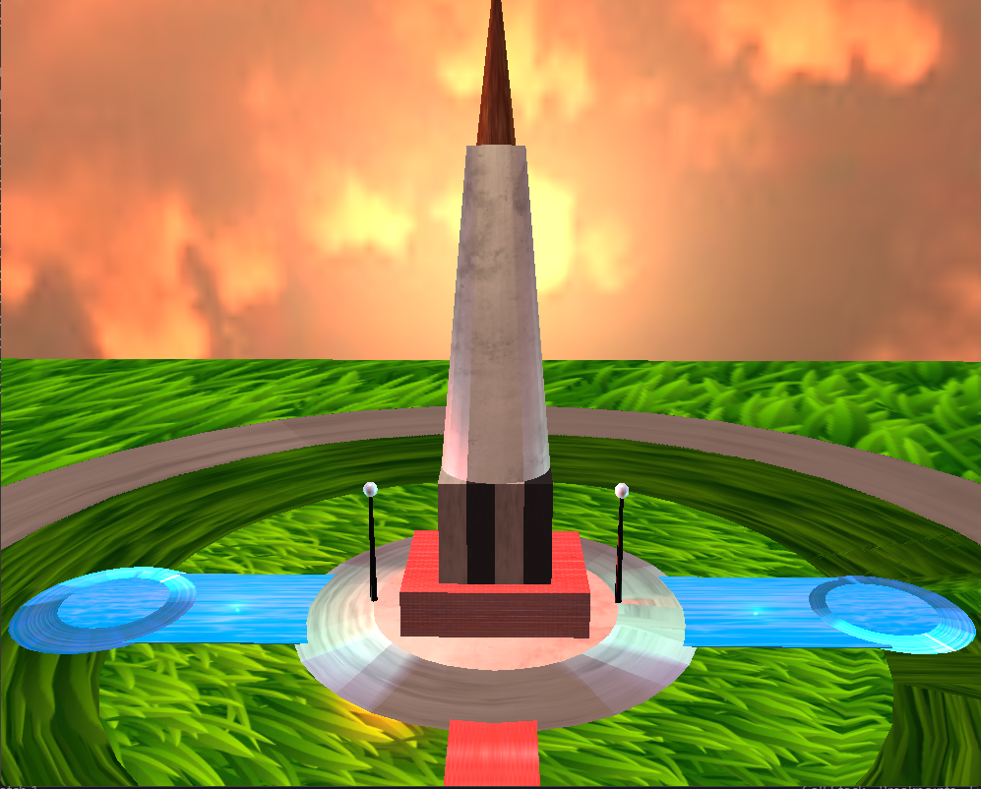

After:
